Priya Pilla, Alex Hoskins, Taya Mata, Quy Vo

Group Name: PATQ

Capstone

User’s Manual for VARK Learning

**Setup and Running the Program**

1. Download and unzip the submission from eLearning on a Mac OS platform (This application was developed on a Mac platform, so the instructions are specific to that. Can also use Linux, but might need some minor adjustments)
2. This submission includes:
   1. README.md
   2. Project1
      1. Templates – HTML files for all the front end
      2. Tests – unit and functional tests for the application
      3. Application.py – Python file that has all the logical functionality for the application to work
      4. Create.py – creates tables from models.py
      5. Create.sql – SQL file created by create.py that has the creation for student table
      6. Models.py – python classes for each table using SQLAlchemy
      7. Requirements.txt – list of required modules
3. Environment: This project has been tested in the Command Line for Mac OS
4. **Running the program**:
   1. Make sure you have Python3.7, Pip3 and FLASK installed on your computer
      1. Installation sites:
         1. Python3.7: <https://www.python.org/downloads/>
         2. Pip3: <https://pip.pypa.io/en/stable/installation/>
         3. FLASK: https://pypi.org/project/Flask/
   2. In the command line, go into the project directory and into project1 folder
   3. Install the modules listed in the requirements.txt file by doing “pip3 install <module name>”
   4. Create virtual environment by this command: “virtualenv -p python3.7 venv” (do this once, don’t have to do this every time you run)
   5. Activate virtual environment: “source venv/bin/activate”
   6. Now the Flask commands: “export FLASK_APP=application.py”
   7. Run: “python -m flask run”
   8. If missing module errors come up do: “pip3 install <module name>”
      1. Examples: “pip3 install flask”, “pip3 install requests”, “pip3 install flask_sqlalchemy”, “pip install psycopg2”
      2. After modules are installed, run with this again: “python -m flask run”
   9. Copy the url “http://127.0.0.1:5000/” given on the command line into your browser to see the application

No command line arguments are required or checked.

**User Input**: User inputs maybe clicking on buttons, entering username, password, text entry for notes, and interaction with radial buttons in learning styles quiz.

Example user inputs:

Buttons:

Text Entry:

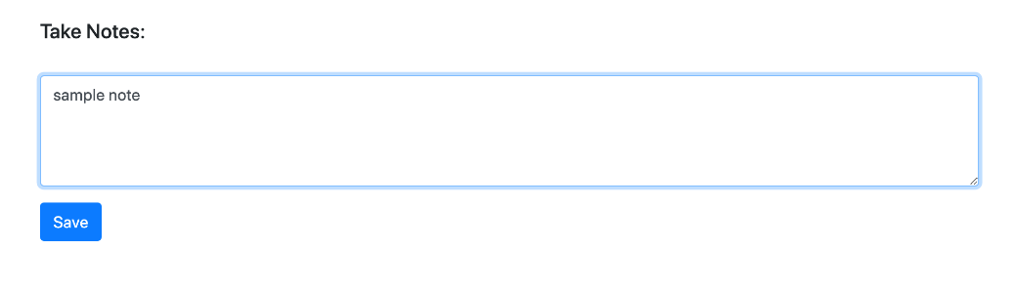

**Output**: Output on the console is GET and POST requests

Other output is the web application GUI that has several pages. Here are some:

